NAGP Cloud Computing Project
Table of content
- Architecture Diagram and application flow
- Networking architecture
- Limitations and Assumptions
- IAM
  - User groups
  - Users
  - Roles
  - Identity providers
- S3
- RDS
- Lambda
- Secrets Manager
- VPC
  - Subnets
  - Route table
  - Internet Gateway
  - Security
    - Network ACLs
    - Security Groups
  - Private Links
    - VPC Endpoints
    - Target Groups
- EC2
  - Instances
  - Images
- ASG (Auto Scaling Groups)
- ALB (Application Load Balancer)
- CloudWatch

Architecture Diagram
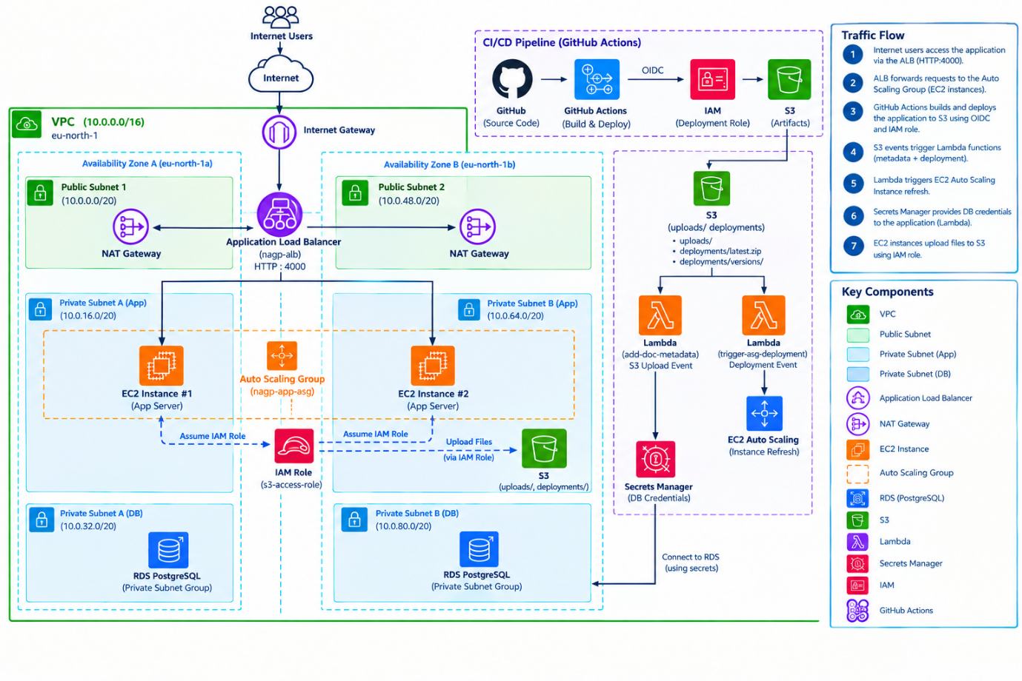
Application Request Flow
- End users access the application through the internet via http://nagp-alb-874942920.eu-north-1.elb.amazonaws.com.
- Traffic enters the AWS environment through the Internet Gateway attached to the VPC (10.0.0.0/16).
- The Application Load Balancer (nagp-alb) deployed across public subnets in both Availability Zones receives incoming requests on port 4000.
- The ALB distributes requests across EC2 instances managed by the Auto Scaling Group (nagp-app-asg) located in private application subnets.
- The Auto Scaling Group maintains application availability by automatically launching, replacing, or terminating EC2 instances based on health checks by target group and scaling policies.
- EC2 instances process application requests and upload files to Amazon S3 using an attached IAM role with S3 permissions. File upload happens in multipart.
- EC2 instances do not communicate directly with the PostgreSQL database.

Database Access Flow
- Uploaded files in Amazon S3 trigger the add-doc-metadata Lambda function through S3 event notifications.
- The Lambda function retrieves database credentials from AWS Secrets Manager.
- Using the retrieved credentials, the Lambda function securely connects to the Amazon RDS PostgreSQL database located in private database subnets.
- Metadata associated with uploaded documents is processed and stored in the database.
Deployment Workflow
- Source code is stored in GitHub.
- A GitHub Actions workflow is triggered during deployment.
- GitHub Actions authenticates to AWS using OpenID Connect (OIDC).
- OIDC assumes the AWS IAM deployment role without requiring long-lived AWS access keys.
- Deployment artifacts are uploaded to the S3 deployment bucket.
- The deployment package is stored under the deployments location in Amazon S3_bucket.
- A deployment event triggers the trigger-asg-deployment Lambda function.
- The Lambda function initiates an Auto Scaling Group Instance Refresh.
- During the refresh process, existing EC2 instances are gradually replaced with new instances running the latest application version.
- The Application Load Balancer continues routing traffic only to healthy instances throughout the deployment process.
Networking Architecture
- Public Subnets
  - 10.0.0.0/20 (eu-north-1a)
  - 10.0.48.0/20 (eu-north-1b)
Host:
  - Application Load Balancer
  - NAT Gateways
- Private Application Subnets
  - 10.0.16.0/20 (eu-north-1a)
  - 10.0.64.0/20 (eu-north-1b)
Host:
  - EC2 Application Servers
  - Auto Scaling Group resources
- Private Database Subnets
  - 10.0.32.0/20 (eu-north-1a)
  - 10.0.80.0/20 (eu-north-1b)
Host:
  - Amazon RDS PostgreSQL
High Availability and Security
- Application components are distributed across two Availability Zones (eu-north-1a and eu-north-1b).
- The Application Load Balancer performs health checks and routes traffic only to healthy instances.
- Auto Scaling automatically replaces failed instances and adjusts capacity based on demand.
- The database is isolated in private subnets and is not directly accessible from application servers.
- Secrets Manager securely stores database credentials.
- GitHub Actions uses OIDC-based authentication, eliminating the need for stored AWS access keys.
- IAM roles provide controlled access to AWS resources, including S3 uploads from EC2 instances.
Limitations
- As NAT Gateway is not available in free tier account we are deploying the zipped deployment artificats from github actions using oidc idp to s3 excluding devDependencies as from ec2 to github connect can’t be established without NAT Gateway in private subnet.
- Used a base ami from an public ec2 for all private ec2 instance which include Node.js 24, pm2, unzip as connection to npm can’t be established.
- Single region deployment (eu-north-1) even though multi region deployment is possible in free tier but resources needs to be duplicated like
  - A second ALB
  - Additional EC2 instances
  - Another RDS database (or cross-region replication)
  - Additional NAT Gateway(s)
  - Additional data transfer
- HTTPS/TLS is not configured because no custom domain name or ACM certificate is currently available.
Technology Selection Assumptions
- Amazon RDS PostgreSQL was selected because the application stores structured metadata.
- As RDS is aws service it can be connected vic ec2 in private subnet via vpc endpoint without NAT gateway any other db I have to install on ec2 itself which will increase compute and cpu usage as internet access was not possible without NAT.

1. IAM – Identity and Access Management
Provides secure access control for AWS resources through users, groups, roles, and policies. IAM enforces least-privilege permissions, enabling authentication and authorization for administrators, applications, and AWS services.
Purpose:
- Manage user and service access to AWS resources.
- Define permissions using IAM policies.
- Support temporary credentials through IAM roles.
Communication:
- Users authenticate via IAM credentials or federated identity providers.
- AWS services assume IAM roles to securely access other AWS resources.
- Policies are evaluated before allowing or denying API requests.
IAM Group: (dev-group)
A collection of IAM users that simplifies permission management by assigning policies to a group instead of individual users.
Attached Policies
Have provided full access of EC2, RDS, S3, VPC, ASG, Lambda, CloudWatch, Alb so nagp-user can create/edit/update these resources for this assignment
IAMReadOnlyAccess provided readOnly access for IAM so any new access should be provided by root user
SecretsCreate: this policy is specific to DB_SECRETS secret in secrets manger to retrieve and list this secret no access to create new secret or edit it
Policy Name | Purpose
AmazonEC2FullAccess | Full access to Amazon EC2 instances
AmazonRDSFullAccess | Full access to Amazon RDS databases
AmazonS3FullAccess | Full access to Amazon S3 buckets and objects.
AmazonVPCFullAccess | Full access to VPC networking resources including subnets, route tables, gateways, and security groups.
AutoScalingFullAccess | Full access to Auto Scaling groups and scaling policies.
AWSLambda_FullAccess | Full access to AWS Lambda functions, triggers, and configurations.
CloudWatchFullAccessV2 | Full access to CloudWatch metrics, logs, alarms, dashboards, and monitoring services.
ElasticLoadBalancingFullAccess | Full access to Application, Network, and Classic Load Balancers.
IAMReadOnlyAccess | Read-only access to IAM users, groups, roles, and policies.
SecretsCreate | Permission to list and get only DB_SECRETS which is managed within AWS Secrets.

IAM User (nagp-dev)
Represents an individual user account that provides authenticated access to AWS resources
Permissions
Apart from permissions provided by iam user-group (dev-group) few inline permissions were also given
Policy Name | purpose
nagp-create-identity-provider | Provides user to create identity provider for github oidc authentication
nagp-dev-ec2-role-management | Provides user to pass, put, attach InstanceRole role to ec2 instances
NagpDev-LambdaRoleSetup | Provides user to pass, put, attach add-doc-metaData role to lambda function

IAM Roles
It is an identity that can be used by aws services with specific permission to perform some operation.
Name | Purpose
add-doc-metaData | Used by lambda functions to read get secrets from secrets manager and get s3 object in specific bucket to read metaData
AWSServiceRoleForAutoScaling | Used for auto scaling
GitHubActionsDeployToS3 | Provides github actions permissions to deploy deployment.zip to s3_bucket/deployment path only
IAM Identity Provider
It allows external resources for authentication without aws credentials it provides temporary token. We used this in github for authentication and use GitHubActionsDeployToS3 role to deploy artificats to s3.
2. S3 Storage
Used for storing Insurance portal documents and deployments artifacts
Bucket name: nagp-insurance-docs-160885278821-eu-north-1-an
uploads/
├── document-1.pdf
├── document-2.jpg
deployments/
├── latest.zip
└── versions/
├── deployment-001.zip
└── deployment-002.zip
- all the documents uploaded from the UI will be stored in uploads folder
- all the deployment artifacts will be stored in deployments folder versions will contains all deployments versions and latest.zip will contain latest deployment artifact which will be deployed to ec2 by ec2 AMI userdata
3. RDS (nagp-db)
Used to store metadata information of all the files added to s3_bucket/uploads path it is in private subnet and only lambda functions can connect to this database as managed by security group inbound rules which will only allow incoming request from lambda security group on port 5432.
Table name: file_medata
Fields: id, file_name, content_type, upload_timestamp
4. Lambda
Functions which are utilized to perform operations in response to events, automatically managing underlying infrastructure, scaling, availability.

Used 3 lambda functions
- view-doc-metadata: used to view records in rds. It used a role to fetch db secrets such as db username and password from secrets manager via vpc endpoint.
- add-doc-metaData: used to insert metadata in rds triggered via s3 event whenever a document is uploaded in s3_bucket/uploads path. It also uses a role to fetch db secrets.
- trigger-asg-deployment: used to trigger auto refresh on auto scaling groups whenever a latest.zip deployment artifact is deployed on s3_bucket/deployments path. It uses a role to initiate https request to ASG via vpc endpoint as NAT is not present due to cost constraint.
5. Secrets Manger
It is used to store db secrets (username and password) which will be accessed via vpc endpoint as lambda’s are in private subnet.
6. VPC
It is a isolated virtual network within AWS, enabling secure communication between application components while controlling network access, routing, and connectivity.
- Subnets
Used to divide vpc into smaller network segments, enabling logical separation of resources based on security, availability, and accessibility requirements.
These are associated with Avalability zones (eu-north-1a, eu-north-1b) to host aws resources.
We used 6 subnets:
2 private for ec2, lambda
2 private for database
2 public subnets for ALB or NAT gateway
- Route table
It controls how network traffic is directed within the Amazon VPC by defining routes between subnets, gateways, and AWS resources.
Used 3 route table to configure incoming/outgoing traffic between subnets and gateway or vpc.
- Internet Gateway
It enables communication between resources within a VPC in public subnet and the public internet.

- Security
  - Network ACLs: It provides stateless network-level traffic filtering for subnets within a VPC, controlling inbound and outbound traffic based on defined rules.
  - Security Groups: It act as virtual firewalls that control inbound and outbound traffic for AWS resources such as EC2 instances, Load Balancers, RDS databases, and Lambda functions within a VPC.
Used several sgs for ssm, alb, ec2, rds, secrets-manager, lambda
- Private Links
    - VPC Endpoints: It enables private and secure connectivity between resources in a VPC and supported AWS services without routing traffic through the public internet, NAT Gateway, or Internet Gateway.
Used 2 endpoints for s3 and secrets manager
    - Target Groups: Used to define the set of resources that receive traffic from a Load Balancer and provide health monitoring to ensure requests are routed only to healthy targets.
Used 1 target group which checks instance health of both availability zones using base Alb DNS.
7. EC2:
Instances: provide the compute resources required to run the application workload
  - AMI (Amazon machine Image): It is a snapshot of existing ec2 instance which can be used to launch new instances with all the configurations present in existing instance.
Used 1 AMI of a public ec2 instance which serves as a base AMI for all the instances launched by ASG. It includes Node.js 24.x, nvm, pm2, unzip.
8. ASG (Auto Scaling Groups): It automatically manages the number of EC2 instances running an application, ensuring high availability, fault tolerance, and scalability based on workload demand.
Used 1 ASG (nagp-app-asg) with capacity configuration:
min: 2, desired: 2, max: 4 with Balanced best effort which ensures same traffic in both instances in diff AZs
We have a dynamic scaling policy with configuration:
Policy type: Target tracking scaling
Execute policy when: As required to maintain Average CPU utilization at 60
Take the action: Add or remove capacity units as required

We are handling Instance refresh once a new deployment artifact is uploaded in s3_bucket/deployments path then trigger-asg-deployment lambda get’s triggered which will use vpc endpoint to communicate with ASG.
after that ASG initiate new instances based on the desired capacity marking current deployed ec2 instances as drained.
new instances will use base AMI and userdata will download the latest artificats from s3 bucket unzip it and then start the server using pm2.
9. ALB (Application Load Balancer): It distributes incoming application traffic across multiple targets, ensuring high availability, scalability, and reliable request handling.
nagp-alb-874942920.eu-north-1.elb.amazonaws.com
10. CloudWatch: It provides centralized monitoring, logging, alerting, and observability for AWS resources and applications, enabling proactive detection and resolution of operational issues.
cloudWatch dashboard used to check health status, request and average CPU utilization for both AZs.
cloudWatch Alarms: used to notify when some condition mets as we use ASG (dynamic autoscaling policy) there are 2 default alarms for checking CPU usage which will alert if CPU usage <40% or > 60%. And also sends email to registered email.

